
WORK AND TIME:
The Four-Day Week —
What We Actually Know
In March 2018, the New Zealand company Perpetual Guardian made 240 employees an unusual offer: work four days, get paid for five, but deliver the same results. The experiment ran for eight weeks and travelled the world. Since then hundreds of companies across dozens of countries — and several governments — have repeated it. And yet, eight years on, we still have no convincing answer to the simplest question: does it work? This report examines each of the major experiments in turn, shows what each one measured and what it did not, and explains why the picture is far more complicated than the headlines suggest.
▌ 01 What the Four-Day Week Is
Let us begin with a definition, because this is where most of the confusion starts. The “four-day week” is not always the same thing. The name today covers three entirely different changes, each with its own logic, its own cost and its own results. Until we separate them, any comparison is meaningless.
The first and loudest is a genuine reduction in working time. Instead of 40 hours a week, an employee works 32 or 35, and pay stays the same. This is the model behind the famous formula — “100-80-100”: 100% of the pay, 80% of the time, 100% of the output. It is what Iceland, the United Kingdom, Portugal, Germany and Scotland were testing.
The second is compression. Hours do not fall — the same 38 or 40 hours are simply packed into four days. That means a ten-hour working day. A person comes to work on fewer days but does not work less. Belgium, the Philippines, the Tokyo Metropolitan Government and the United Arab Emirates are doing exactly this.
The third and largest in scale is a statutory reduction of the working week across an entire country. There is no pilot and no volunteering here: parliament simply changes the norm, say from 48 hours to 40, and it applies to every employer. Mexico, Chile, Colombia and South Korea are doing precisely that today. This report deals with the first two types — these are the ones actually called a four-day week.
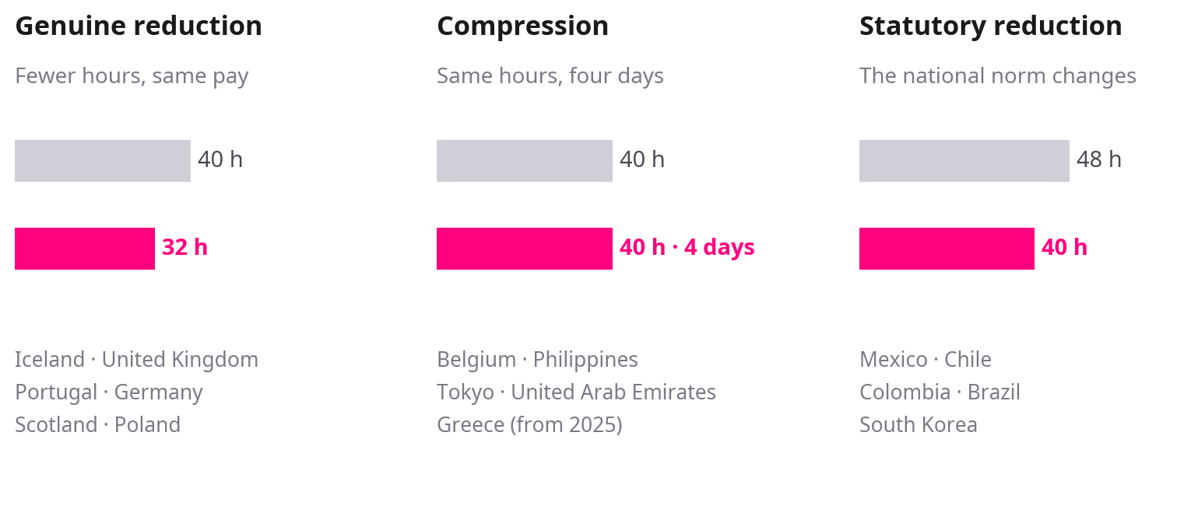
Figure 1. Three reforms that go by the same name.
Why should the first, most contested version work? The proponents’ logic runs like this: a five-day week wastes a great deal of time — in unnecessary meetings, in switching between tasks, in those tired hours when a person is formally at work but effectively producing nothing. For the employer the appeal is even more practical: a four-day week attracts talent and requires no investment.
All of this sounds convincing. The problem is that testing it has proved far harder than it first appears — and that is where we have to start.
▌ 02 Methodology
Imagine you are testing a new diet, but you recruit only people who want to lose weight and already believe it will work. The result will of course be good. It just will not tell you whether the diet would work for anyone else.
Every large four-day-week experiment is built exactly this way. A company applies to take part. Before it applies, it runs the numbers internally: do we have slack in our workload, can we cut meetings, will we need to hire? If the answer is no, the company simply does not participate. The result is that the experiment fills up with precisely those firms where the model has the best chance. The average result comes out better than it would if the change were introduced for everyone at once. The researchers themselves say so explicitly.
The second problem is the comparison group. A good study needs a second, similar group that does not undergo the change. It is needed to show what would have happened anyway — perhaps the market picked up during those six months, or perhaps it fell. Most four-day-week experiments have no such group at all.
The third is how the result is measured. It is one thing to ask a person whether they sleep better. It is quite another to measure their sleep with a device. It is one thing to ask a manager whether productivity changed. It is quite another to look at the accounts. Self-assessment is not useless — employee satisfaction is a real indicator — but it cannot confirm that the company delivered the same volume of work.
In 2023 the European Commission’s Joint Research Centre reviewed every experiment then available and concluded that they offer only an indicative picture, and that drawing policy conclusions from them is premature. So before turning to the individual experiments, it is worth ranking them by how each one was built — rather than by which is better known.
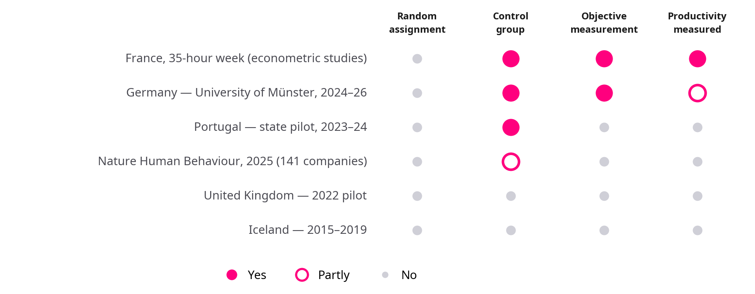
Figure 2. The main four-day-week studies, ranked by how each was designed.
The picture is clear: the more rigorously a study is built, the less well known it is. The loudest numbers come precisely from the places with neither a comparison group nor instrument-based measurement. The next seven chapters examine these experiments one by one — beginning with the one cited most often.
▌ 03 Iceland
When people discuss the four-day week, Iceland is almost always the first example. “Iceland tried it and it worked” — that sentence appears in thousands of articles. Almost every part of it needs qualifying.
The facts are these. Reykjavík City Council in 2015 and the national government in 2017 ran two separate trials. Together they involved more than 2,500 employees across more than 60 workplaces — offices, preschools, social services, hospitals, the police. That is roughly one percent of the country’s workforce. The results were positive: service quality was maintained or improved, stress and burnout fell noticeably, and the trials proved budget-neutral for both the city and the state.
In Iceland the working week fell from 40 hours to 35–36 — that is, by one to four hours a week. Anthony Veal, a researcher at the University of Technology Sydney, showed that in 61 of the 66 workplaces the reduction was only one to three hours. That is not a four-day week in any sense. The Icelandic report’s own title says “shorter working week,” not “four-day.” The name was attached to it by the British and American press.
The second common error concerns the figure of 86% — as though 86% of Icelanders now work four days. In reality that number means that 86% of the workforce either reduced their hours or gained the right to do so. Actual take-up is different: according to the same authors’ 2024 report, 51% actually took the shorter hours between 2020 and 2022. Iceland’s statutory 40-hour norm remains unchanged to this day — the change came through collective agreements, not legislation.
Iceland’s example is real — but it is an example of a modest reduction in working time, not of a four-day week.
▌ 04 The United Kingdom
From June to December 2022 the United Kingdom hosted what remains the most frequently cited experiment: 61 companies, roughly 2,900 employees, six months. It was organised by 4 Day Week Global and the research centre Autonomy, together with researchers from Cambridge and Boston College. The model was the classic one: 100% of the pay, 80% of the time, 100% of the output.
The results look impressive. Of the 61 companies, 56 said they would continue and 18 made the change permanent immediately. Some 71% of employees reported reduced burnout. A year later, in 2024, 89% of those surveyed were still operating the same arrangement.
The best-known figure — “revenue rose by 35%” — really does appear in the report. But it compares the months of the trial with the same period in 2021, that is, during the pandemic, when many companies’ turnover was depressed. It was also submitted by only 24 of the 61 participants. A few pages further on in the same report there is another number: comparing the start and the end of the trial itself — that is, what the change actually delivered — growth was 1.4%.
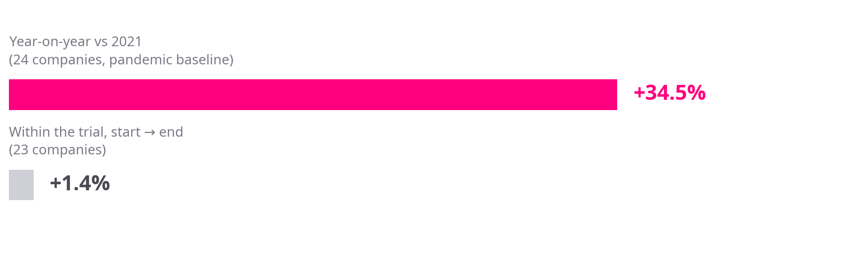
Figure 3. “35%” and “1.4%” — two numbers from the same report, two different measurements.
The second well-known figure — “sick days fell by 65%” — is also in that report. And right beside it, the authors themselves note that it is not reliable: the sample is so small that the difference could be pure chance. The German study, which measured the same thing more carefully, found no change at all.
And finally, something recorded in the same report that almost never reaches the articles. 62% of employees said the pace of work increased. 22% said burnout got worse. 16% said their wellbeing declined. In other words, for roughly one person in five the change made work harder, not easier. This is also logical: if the same volume of work has to fit into four days, the pace necessarily rises.
The British story does have one genuine long-running case. South Cambridgeshire District Council began its trial in January 2023 and made it permanent policy on 17 July 2025. An independent evaluation by the Universities of Salford, Bradford and Cambridge found that 21 of 24 monitored services improved or held steady; the council saved roughly £400,000 a year, staff turnover fell by 41% and job applications rose by 123%.
However, in October 2025 the Local Government Secretary, Steve Reed, wrote to the council citing different indicators from that same independent report: deterioration in rent collection, re-letting times and tenant satisfaction. Both sides rely on the same document and reach opposite conclusions.
▌ 05 The Nature Human Behaviour Study
In July 2025 the journal Nature Human Behaviour published what is now regarded as the field’s most serious scientific paper. The study by Wen Fan, Juliet Schor and co-authors covered 141 companies, 2,896 employees and six countries: the United States, Canada, the United Kingdom, Ireland, Australia and New Zealand. It is the first time four-day-week results have appeared in a peer-reviewed scientific journal rather than in an organiser’s report.
The results are unambiguously positive. After six months people were less burnt out, more satisfied with their jobs and rated their own mental and physical health more highly. Twelve months on, this was sustained.
The most convincing detail is this: the more hours a given individual lost, the more their burnout fell. In science this is called a dose-response relationship, and it is a serious argument. If the effect were explained purely by people being excited about the change, it would be the same for everyone regardless of how many hours they lost. Here the effect tracks the dose.
One thing, though, was not measured at all — productivity. The authors asked employees how they rated their own work ability. Revenue, output and the volume of work completed were not collected. The control group consisted of 12 companies that did not reduce hours — a partial comparison, but not random assignment.
This is partly a genuine difficulty. Measuring productivity in knowledge work really is hard: the “output” of a marketing agency or a consultancy does not translate into a simple number. But difficulty does not mean we have the answer. It means we do not.
So the correct reading of this study is: it convincingly confirms that reducing working time improves how people feel. It says nothing about whether this costs the company anything. The next study was conducted precisely to fill that gap.
▌ 06 Germany
In February 2024 Germany launched an experiment that differed from the others in one fundamental decision. Professor Julia Backmann of the University of Münster studied 41 organisations and decided that questionnaires alone would not do. Participants were fitted with fitness trackers. Hair samples were taken from 256 people — the most reliable way to establish long-term stress levels. And companies were asked for their accounting records.
Where others asked people how they slept, the Germans measured how much they slept. That is what makes this study the most interesting — and the most uncomfortable.
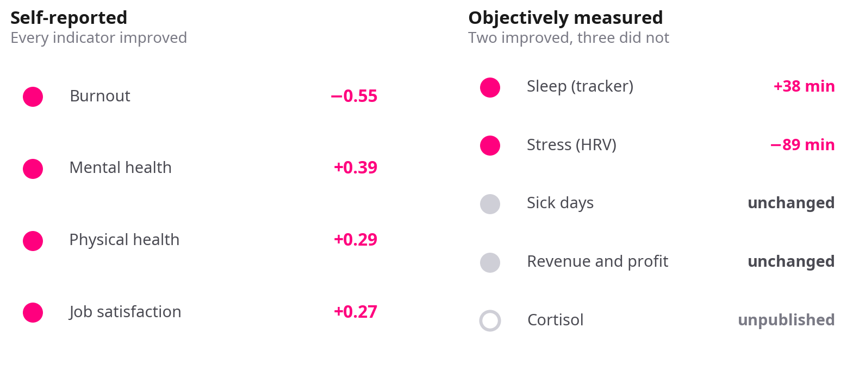
Figure 4. Two pictures of the same reform: on the left, what employees rated themselves; on the right, what instruments and records measured.
The instruments confirmed two things. Participants slept on average 38 minutes more per week. Time spent under stress fell by 89 minutes a week. That is a real, measured improvement.
The rest was not confirmed. Sick days did not fall — which is surprising if people genuinely feel better. Revenue and profit, in the 12 organisations that shared figures, were unchanged. No environmental benefit appeared either: domestic travel actually rose, because people travelled on their free day.
Two years later, in February 2026, the Münster team went back to the same organisations. They reached 40 of the 41 and asked a simple question: were they still running the same model?
30%
of companies had returned to their previous working schedule within two years. A further 22% kept reduced hours but changed the model — replacing a fixed four-day week with a monthly hours quota or a rota.
The reasons are entirely practical: workload peaks, unstable order books, difficulty meeting deadlines. As one organisation put it: “During busy periods we could not manage reliable delivery on reduced hours.” This is precisely the problem a six-month experiment cannot see.
And here is one detail that changes the whole picture. In the German experiment the average reduction was less than four hours a week — meaning most participants never moved from five days to four at all. 40% of the organisations applied the reform only to selected teams. This is the same problem as in Iceland: what we call a “four-day week” is often a far more modest change.
“I am not of the view that every organisation should now move to a four-day week.”
Julia Backmann, University of Münster — lead researcher of the German study
▌ 07 Portugal
The Portuguese experiment stands out for one reason: the state gave the companies no money. From June to November 2023 the Ministry of Labour coordinated a pilot involving 41 companies and more than 1,000 employees, with no subsidy. The evaluation was carried out by independent researchers — Pedro Gomes of Birkbeck and Rita Fontinha of Henley Business School.
This matters because the absence of a subsidy removes one doubt: companies did not stay in the programme because they were being paid to. And the retention really is striking — 89% continued or extended the arrangement, and of the 21 firms in the coordinated pilot only four returned to a five-day week.
Actual hours fell too, not just formally: the working week came down from over 41 hours to 36.5, a fall of 12%. The share working more than 40 hours dropped from 79% to 20%. Those rating their mental health “very good or excellent” rose from 15% to 30%. Sleep increased by 11 minutes a night. 93% of employees rated the trial positively, and valued the benefit itself at 28% of their salary — meaning a free day was worth close to a third of a pay rise to them.
The managers’ side is reassuring too: 80% said the change was financially neutral, and 40% even identified savings. 75% of companies redesigned their work processes.
What is missing? Everything discussed in the earlier chapters. No control group, no random selection, and productivity was not measured objectively — the assessment rests on managers’ opinions. And almost every health indicator is self-reported.
▌ 08 Spain, Scotland and Poland
When a government says it is testing the four-day week, we usually picture a large-scale programme. In practice it often ends very differently.
In December 2022 Spain announced a €10 million programme for 60–70 industrial small and medium-sized enterprises. The condition was a reduction of at least 10% in hours with pay maintained, sustained for at least two years. Forty-one companies applied. In September 2024 funding was finally awarded to five, totalling roughly €530,000 — about five percent of the budget. The results from those five companies have never been published.
Valencia is often cited under Spain’s name too. In April and May 2023 the city moved four local public holidays to four consecutive Mondays, creating four four-day weeks. This was not a reduction in working time — it was an extended weekend. The results (less traffic, less nitrogen dioxide, more sleep) are interesting but say nothing about the four-day week. Nationally, a bill for a 37.5-hour week was rejected by parliament on 10 September 2025.
Scotland’s story is interesting in a different way. Two government agencies — the Accountant in Bankruptcy and South of Scotland Enterprise — ran a year-long trial of a 32-hour week. The results were good: mental health scores improved by 18%, work stress fell by 18%, days absent through psychological illness fell from 357 to 265 a year, and service performance was largely maintained.
And yet on 28 August 2025 the Public Finance Minister, Ivan McKee, announced that the Scottish Government would not be moving to a 32-hour week. This is an important observation: even a good result does not automatically become policy, because in the public sector the central question is cost — who pays for the additional staff in services where there is no slack in the workload.
The largest live government programme today is in Poland. In 2025 the Ministry of Family, Labour and Social Policy announced a PLN 50 million programme. Applications came from 1,994 organisations, of which 90 were selected — 4.5%. Eighty eventually signed contracts: 40 private companies and 40 public bodies, covering more than 5,000 employees. Testing runs throughout 2026 — hours fall by 10% in the first half and 20% in the second. The final report is due by May 2027.
So Poland’s results do not yet exist. Any figure circulating today as a “result of the Polish pilot” is premature. What the selection statistics already tell us, though, is this: choosing 90 from 1,994 applicants means the participants are even more strongly selected than in a typical pilot — which sharpens the same self-selection problem still further.
One historical example is also worth recalling. At the Svartedalen care home in Gothenburg, Sweden, around 70 nurses worked a six-hour day at full pay for 18 months in 2015–2016. Health indicators improved and sick leave fell. The experiment was not continued: in care work there is no slack in the workload, and the city had to hire 17 additional staff at a cost of roughly $1.3 million. This is exactly the case where the “wasted time” logic fails — a nurse’s working day does not contain unnecessary meetings.
▌ 09 Belgium, Japan and Greece
Now back to the second type — compression. Here hours do not fall and, accordingly, the “100-80-100” logic does not apply at all. Even so, international reviews frequently list these countries alongside the others.
In Belgium, since November 2022 an employee has had the right to request that their 38-hour week be packed into four days — a maximum of 9.5 hours a day. The employer may refuse, the agreement runs for six months and must be renewed each time. The result: two years on, only 0.75% of employees were using the right, and 2.75% of companies had at least one such employee.
A qualitative study by Ghent University is more interesting still. Seven of the 15 employees interviewed said their flexibility had actually decreased: they had previously been able to choose their start and finish times, and now had a rigid, extended schedule. A reform whose stated aim was greater flexibility delivered the opposite for some of those it covered.
Belgium was also meant to run a genuine hours-reduction pilot in parallel, by the Federal Planning Bureau and Ghent University. Around 500 people attended the recruitment webinars, ten organisations began preparation, and in the end only five remained, mostly NGOs. Half withdrew once they saw the legal and technical complexity of the model. No results have been published.
Japan is often cited as a country that “adopted” the four-day week. In fact the government merely wrote it into its 2021 economic policy guidelines as a recommendation. According to the Ministry of Labour, around 8% of companies offer three or more days off a week. Actual take-up is microscopic: of Panasonic’s 63,000 eligible employees, 138 used the programme in the 2024 financial year — down from 153 the year before. From April 2025 the Tokyo Metropolitan Government offered its staff three days off a week while maintaining 155 working hours a month — which is, again, compression.
It is worth pausing here on the figure repeated most often in the whole debate: “Microsoft Japan’s productivity rose by 40%.” This was a one-month experiment in August 2019 with 2,300 employees. The figure is a comparison of sales per employee against the previous August. There was no control group, no adjustment for seasonality, and productivity is not measured by sales. Microsoft Japan never made the four-day week permanent.
And finally Greece, which went in the opposite direction. From 1 July 2024 a six-day week was permitted in certain sectors, and in October 2025 parliament also authorised a 13-hour working day. The paradox is that the same law legalised a voluntary four-day, ten-hour week. So Greece simultaneously has the longest actual working week in the EU — 39.6 hours against an EU average of 35.9 — and a legal route to a four-day week. It shows how little the name itself means.
▌ 10 Conclusions
After eight years and dozens of experiments, the picture arranges itself as follows.
First, what is confirmed: reducing working time improves how people are. This conclusion comes simultaneously from several independent studies, including the only peer-reviewed scientific paper and the only study in which sleep and stress were measured by instruments. Germans slept 38 minutes more a week, the Portuguese 11 minutes more a night, and burnout fell further the more hours a person lost. This is a real benefit and it is no longer seriously in doubt.
Second, what is not confirmed: that this costs the company nothing. That is the idea’s central promise — “100% of the output” — and it is the worst-measured part of it. The largest study did not measure productivity at all. The only study that looked at accounting records found no change. The best-known figure — 35% — turned out to be an artefact of measurement. The second best-known — Microsoft Japan’s 40% — is a one-month comparison with no control group.
Third: six months is a short horizon. In the only independent two-year follow-up, 30% of participants had reverted and a further 22% had changed the model. The reasons are ones a short experiment cannot see: seasonal peaks, unstable order books, deadlines.
Fourth: a “four-day week” is often not a four-day week. In Iceland hours fell by one to three a week, in Germany by less than four on average, and in Belgium, Tokyo and the Philippines they did not fall at all. This is not a terminological quibble but a measurement problem: we are pooling the results of different interventions under a single name.
Fifth: the recruitment argument is real but not durable. A four-day week genuinely does increase applications and reduce turnover — precisely because others are not offering it. That is a competitive advantage, not a productivity gain, and it disappears of its own accord once adoption becomes widespread.
What would settle the argument? A study in which companies were randomly assigned to two groups and productivity was measured from accounting records, over at least two years, within the same sector. No one has yet conducted such a study. Until one exists, the four-day week remains what it is: a probably beneficial reform for the employee, of unproven value to the employer.
▌ 11 Sources
1. Acerta Consult. Four-Day Week Uptake in Belgium, October 2024.
2. Autonomy. Making It Stick: The UK Four-Day Week Pilot One Year On, 2024.
3. Autonomy, 4 Day Week Global, University of Cambridge, Boston College. The Results Are In: The UK’s Four-Day Week Pilot, 2023.
4. Autonomy & Alda. Going Public: Iceland’s Journey to a Shorter Working Week, 2021.
5. Autonomy & Alda. On Firmer Ground: Iceland’s Ongoing Experience of Shorter Working Weeks, October 2024.
6. Backmann J et al. 4-Day Week Germany-Wide Pilot Study — Pilot Report. University of Münster, 2024.
7. Backmann J et al. 4-Day Week Germany — Two-Year Follow-Up Report. University of Münster, February 2026.
8. Baker D. Productivity and the Four Day Workweek. Center for Economic and Policy Research, 2022.
9. Campbell TT. The Four-Day Work Week: A Chronological, Systematic Review of the Academic Literature. Management Review Quarterly 74(3), 2024.
10. Chemin M, Wasmer E. Using Alsace-Moselle Local Laws to Build a Difference-in-Differences Estimation Strategy of the Employment Effects of the 35-Hour Workweek Regulation in France. Journal of Labor Economics 27(4), 2009.
11. CNBC. Microsoft Japan Tested a Four-Day Work Week and Productivity Jumped by 40%, November 2019.
12. Cuello H. Assessing the Validity of Four-Day Week Pilots. European Commission, Joint Research Centre, JRC133008, 2023.
13. Estevão M, Sá F. Are the French Happy with the 35-Hour Workweek? IZA DP No. 2459, 2006.
14. Eurostat. Average Work Week Nearly 36 Hours in the EU in 2025, 27 May 2026.
15. Fan W, Schor JB, Kelly O, Gu G. Work Time Reduction via a 4-Day Workweek Finds Improvements in Workers’ Well-being. Nature Human Behaviour, 2025.
16. Gomes P, Fontinha R. Four-Day Week: Results from the Portuguese Trial — Final Report. Henley Business School / Birkbeck, July 2024.
17. Kremalis Law Firm; Ius Laboris. Greece: Law 5053/2023 and Law 5239/2025 on Working Time, 2024–2025.
18. Library of Congress. Iceland: Shorter Working Week Trials — FALQs, January 2022.
19. Lorentzon B. Six-Hour Working Day Trial, Svartedalen — Evaluation. City of Gothenburg, 2017.
20. Ministerio de Industria y Comercio / Fundación EOI. Programa piloto de reducción de jornada laboral — resolución, September 2024.
21. Ministerstwo Rodziny, Pracy i Polityki Społecznej (Poland). Pilotaż skrócenia czasu pracy — nabór i wyniki, 2025.
22. Ministry of Health, Labour and Welfare (Japan) / PBS NewsHour. Japan’s Four-Day Week Uptake, 2024–2025.
23. OECD. Average Annual Hours Actually Worked per Worker, 2024.
24. Scottish Government. Public Sector Four-Day Working Week Pilot — Evaluation and Ministerial Statement, August 2025.
25. UGent@Work. Policy Brief 14: The Compressed Four-Day Week in Belgium, November 2023.
26. Universities of Salford, Bradford and Cambridge. Independent Evaluation of the South Cambridgeshire District Council Four-Day Week, July 2025.
27. Veal AJ. The 4-Day Work-Week: The New Leisure Society? Leisure Studies 42(2), 2023.
28. Veal AJ. The Success of Iceland’s “Four-Day Week” Trial Has Been Greatly Overstated. The Conversation, 2021.

This analysis was prepared by the academic team of the Business and Technology University (BTU) and BTUAI. It draws on publicly available sector reports and research and is analytical in nature.
Citation: Business and Technology University (BTU) and BTUAI. (2026). The Four-Day Week — What We Actually Know. Tbilisi, Georgia.

