
Labour Market and Technology:
Artificial Intelligence and the Future
of Georgia's Labour Market
▌ 01 What this report is about
This report answers one question: which occupations will see demand fall, rise or stay unchanged in Georgia by 2030. Unlike similar overviews, the conclusions here are not based on general impressions but on the primary microdata of Georgia's Labour Force Survey. Every occupation is classified under ISCO-08, which allows global forecasts to be mapped directly onto the structure of the Georgian labour market.
▌ 02 Method: two global sources, one Georgian dataset
The classification is built by reconciling two independent sources. The first is the World Economic Forum's Future of Jobs 2025, which asks more than 1,000 employers across 55 economies which occupations will grow and which will decline by 2030. The second is Working Paper 140 of the International Labour Organization (2025), which assigns each ISCO-08 occupation a degree of exposure to artificial intelligence, based on an assessment of its individual tasks.
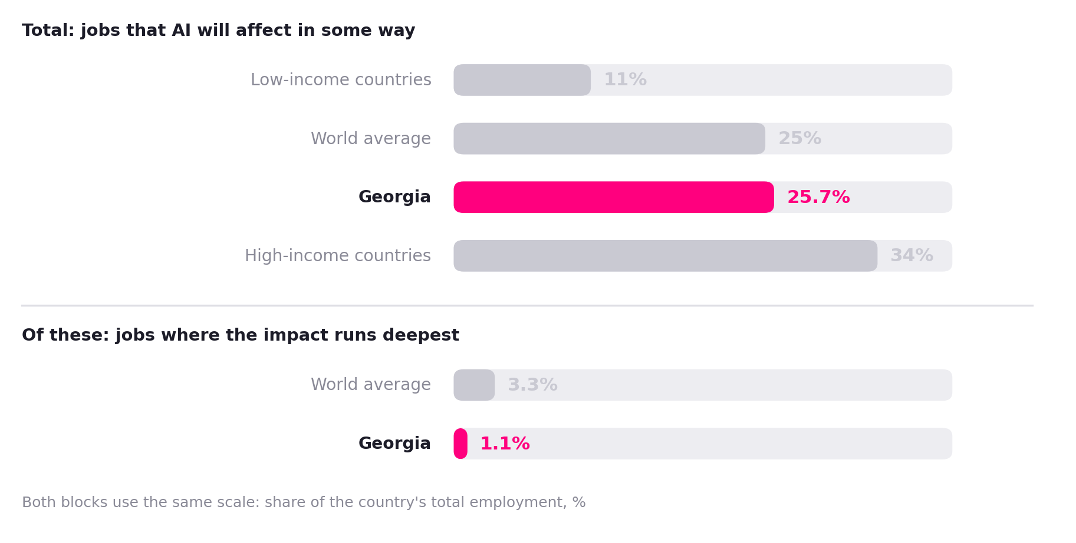
Figure 1. What share of the labour market AI will affect: Georgia in international context (ILO, 2025).
The chart reads in two parts. The upper part shows the share of jobs that artificial intelligence will touch at all, meaning where the way the work is done will change at least in part. Georgia's figure here is 25.7%, which is practically identical to the world average (25%). The first impression is that the country's labour market is in line with international trends.
The lower part says something different. It shows only those jobs where the impact is not superficial but deep, meaning where a large share of the tasks could be performed automatically. In this narrow group Georgia's share is 1.1%, against a world average of 3.3%, three times lower.
▌ 03 Six categories: the results
To make the picture concrete, every occupation present in Georgia was sorted into one of six groups. Each group was defined by two questions: first, whether global demand for that occupation is rising or falling, and second, how deeply artificial intelligence reaches into the everyday tasks of that occupation. As a result, the first two categories are declining, the fourth stays unchanged, and the fifth and sixth are growing.
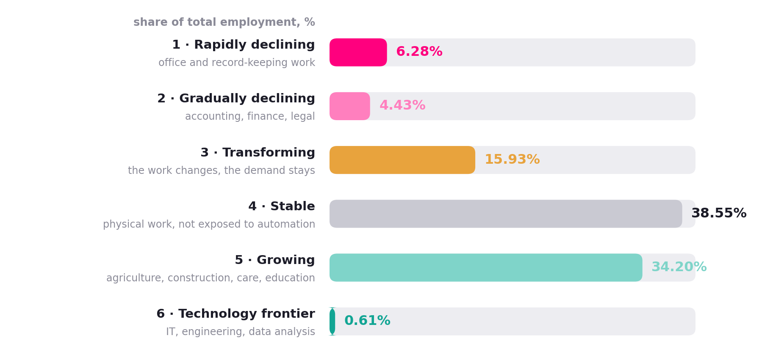
Figure 2. The distribution of Georgian employment by 2030 outlook (Geostat, Labour Force Survey 2025, weighted).
The chart brings out one central number: the technology frontier accounts for just 0.61% of all employment. These are the occupations the World Economic Forum identifies as the fastest growing worldwide, namely programming, engineering and data analysis. In Georgia they employ a total of 8,4K people.
To put that scale in perspective: the entire category is smaller than the single occupation “cashiers and ticket clerks”, in which 16K people work.
▌ 04 The central finding: a mismatch
So far the figures have looked reassuring. The picture changes once we ask a different question: who are the people working in the declining occupations, and who are the people working in the growing ones? It turns out that these two groups have almost nothing in common.
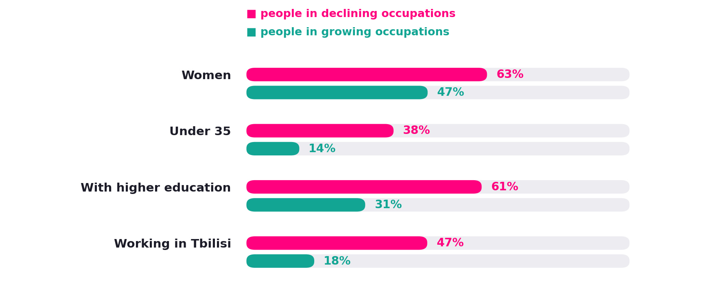
Figure 3. Who works in declining and who in growing occupations.
Roughly 63% of those in declining occupations are women, while women make up 44.6% of total employment. In the same group two thirds hold a higher-education degree and almost half work in Tbilisi. This is largely a young, educated, formally employed urban population.
The people in growing occupations are entirely different: they mostly live in rural areas, are older, more than half are self-employed, and only a third hold a higher-education degree. In sectoral terms, these are agriculture, construction and the care sector.
This is precisely where the main problem lies. When people say that “the jobs that are lost will be created elsewhere”, the assumption is that a person moves from one field to another. In Georgia that move is practically impossible, because the difference between the two groups is not only occupational but also one of location, age, education and form of employment. An accountant in Tbilisi who loses their job cannot become a farmer in Kakheti.
▌ 05 Young people and the first rungs of a career
It matters particularly where young people work. If they are concentrated in declining occupations, that means the change will reach them first.
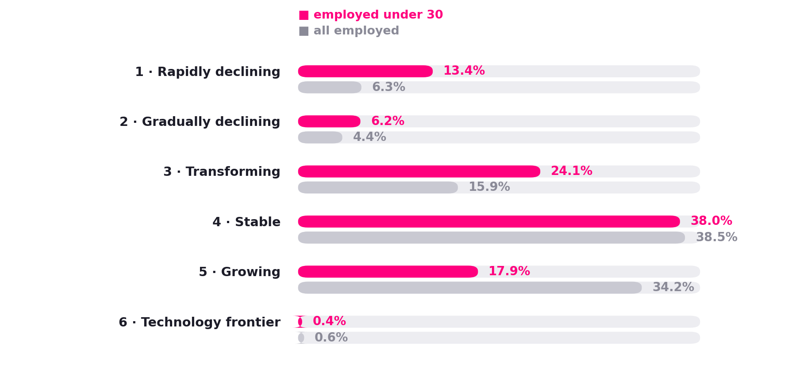
Figure 4. Where young people work: employed under 30 compared with all employed.
The chart shows two bars: the pink one is the share of employed young people working in each category, the grey one is the same for all employed. In the rapidly declining category young people are twice as numerous as all employed (13.4% against an average of 6.3%), while in the growing category they are almost twice as few (17.9% against an average of 34.2%).
This is no accident. Artificial intelligence performs best exactly on those tasks that are simple, repetitive and entry-level: preparing documents, entering data, producing first-draft reporting. These are precisely the tasks normally assigned to a junior employee. In other words, AI erodes first the very rung by which a graduate enters the labour market.

Why this is the main risk
When the first rungs of a career become harder to reach, a young person does not usually stay unemployed but leaves the country. It is exactly this group, young, university-educated and formally employed, that finds it easiest to move abroad. For that reason the effect of artificial intelligence in Georgia is likely to show up not in rising unemployment but in the migration figures.
▌ 06 How robust is this assessment
Any classification of this kind rests on a number of judgement calls, so it should be said honestly where it is weak. A large part of the result depends on three occupations: mixed-farming farmers (7.9% of all employment), shop sales assistants (4.5%) and secondary school teachers (3.5%). Together these three account for 15.9% of all employment, and assigning them to a particular group is a matter for debate.
For example, the World Economic Forum lists farming as a growing occupation, though globally this is driven by food security rather than by the modernisation of agriculture. If farmers are moved from the growing category into the stable one, the growing category falls from 34.8% to 26.9%. It is therefore more reliable to look only at those occupations whose classification is not disputed.
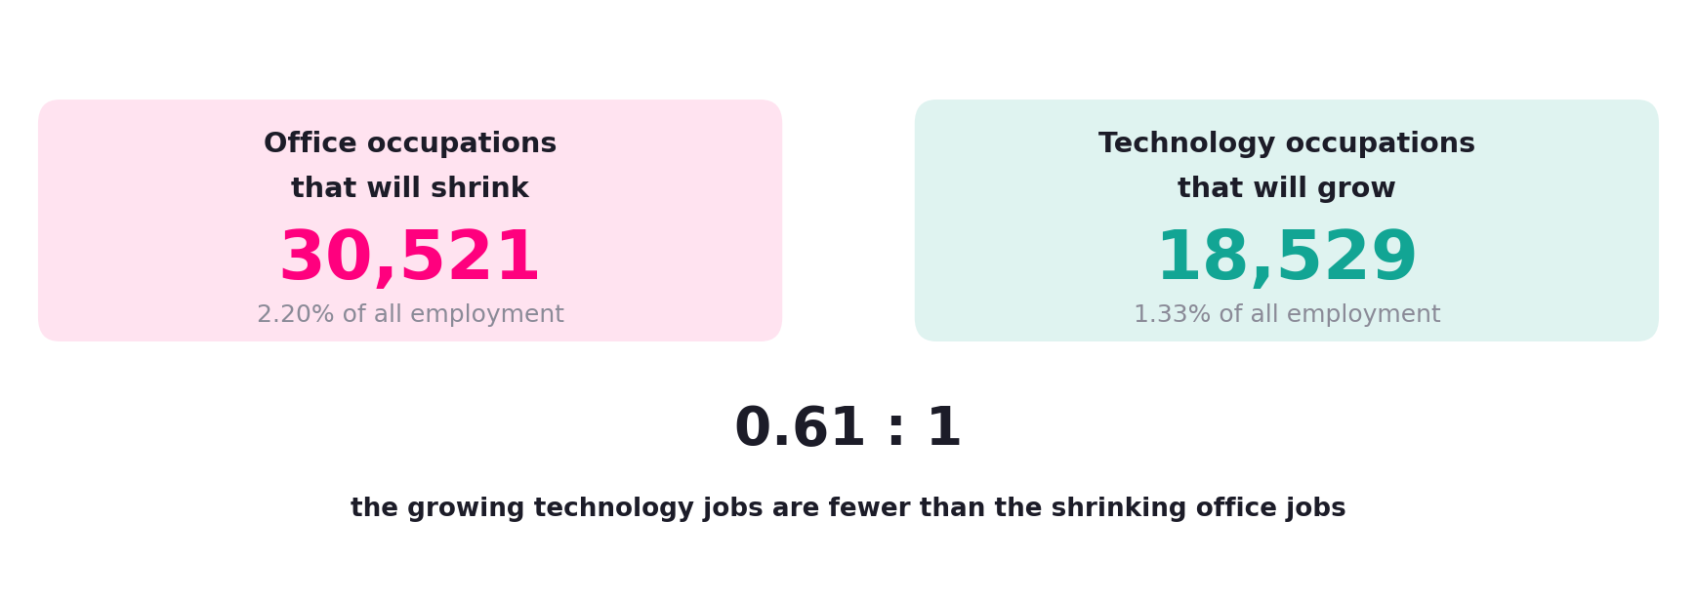
Figure 5. The occupations whose classification is not in dispute.
The result is the opposite of what the overall picture would suggest. The genuinely growing technology occupations employ 18,5K people, while the genuinely declining office occupations employ 30,5K. In other words, the field that is supposed to absorb the people released is itself smaller than the field they would be released from.
This is why the headline figure in this report is 0.61:1 rather than the more optimistic 3.2:1. The latter depends entirely on whether subsistence agriculture and school teaching are counted as growing fields.
▌ 07 Limitations
This assessment should be read with several caveats. First, no Georgian companies took part in the World Economic Forum's survey, so applying the global direction of travel to Georgia is an assumption rather than an observation.
Second, the ILO index is calibrated on Polish data, which the authors regard as the upper bound of automation potential. The everyday work of a Georgian accountant is today less digitised than that of a Polish counterpart, which means our estimate is likely to be overstated rather than understated.
Third, only a single year of data is available, so we cannot say whether the decline in office employment has already begun. Fourth, the division into six categories is the authors' own: neither the Forum nor the ILO publishes such a scheme. Fifth, the survey measures only where people work today and does not show what vacancies employers are advertising.
And finally, the most important point: being exposed to AI does not mean losing the job. An occupation is a bundle of different tasks, and it is precisely this variety that protects it from full automation. More often it is not the occupation itself that changes, but the way it is performed.
▌ 08 Conclusion for Georgia
The widespread fear that artificial intelligence will cause mass unemployment is not supported by this data. The declining categories account for a total of 10.7% of employment, and even under the strictest assumptions displacement by 2030 would not exceed two percent of employment. That is a small number against an unemployment rate of 13.9%.
The real problem lies elsewhere and it is structural. About two thirds of Georgian employment sits beyond the reach of automation, which at first glance means safety. But for the same reason these jobs also remain beyond the reach of productivity growth: artificial intelligence can neither replace them nor improve them. The country is insured against the risk, but at the same time against the gain.
▌ 09 Sources
1. Gmyrek, P., Berg, J., Kamiński, K., Konopczyński, F., Ładna, A., Nafradi, B., Rosłaniec, K., Troszyński, M. (2025). Generative AI and Jobs: A Refined Global Index of Occupational Exposure. ILO Working Paper 140. Geneva: International Labour Office.
2. International Labour Organization (2025). Generative AI and jobs: A 2025 update. Research Brief, May 2025.
3. World Economic Forum (2025). The Future of Jobs Report 2025. Geneva, January 2025.
4. World Economic Forum (2025). Future of Jobs Report 2025: These are the fastest growing and declining jobs. Forum Stories, 9 January 2025.
5. National Statistics Office of Georgia (Geostat). Labour Force Survey, 2025 (primary microdata, LFS_ECSTAT, 58,170 records).
6. National Statistics Office of Georgia (Geostat). Description of the Labour Force Survey database fields, 2025.
7. International Labour Organization. International Standard Classification of Occupations (ISCO-08). Geneva.
8. Autor, D. (2015). Why Are There Still So Many Jobs? The History and Future of Workplace Automation. Journal of Economic Perspectives.
9. Eloundou, T., Manning, S., Mishkin, P., Rock, D. (2024). GPTs are GPTs: Labor Market Impact Potential of Large Language Models. Science.
10. Felten, E., Raj, M., Seamans, R. (2021, upd. 2023). Occupational Heterogeneity in Exposure to Generative AI.
11. Acemoglu, D. (2024). The Simple Macroeconomics of AI. Economic Policy.
12. Bessen, J. (2016). How Computer Automation Affects Occupations: Technology, Jobs, and Skills. Boston University School of Law.

